Why Gridspark Solutions Feels Like the Right AI Partner (Not Just Another Tech Company)
Let’s talk honestly for a second.
When people hear “AI solutions,” it can feel intimidating. Big words. Big promises. Big price tags. And somewhere in the middle of all that, you’re just trying to figure out one simple thing:
Will this actually help my business?
That’s the real question.
AI shouldn’t feel complicated or overwhelming. It shouldn’t feel like something only large tech companies understand. It should feel practical. Useful. Clear. And that’s exactly where GridSpark Solutions comes in.
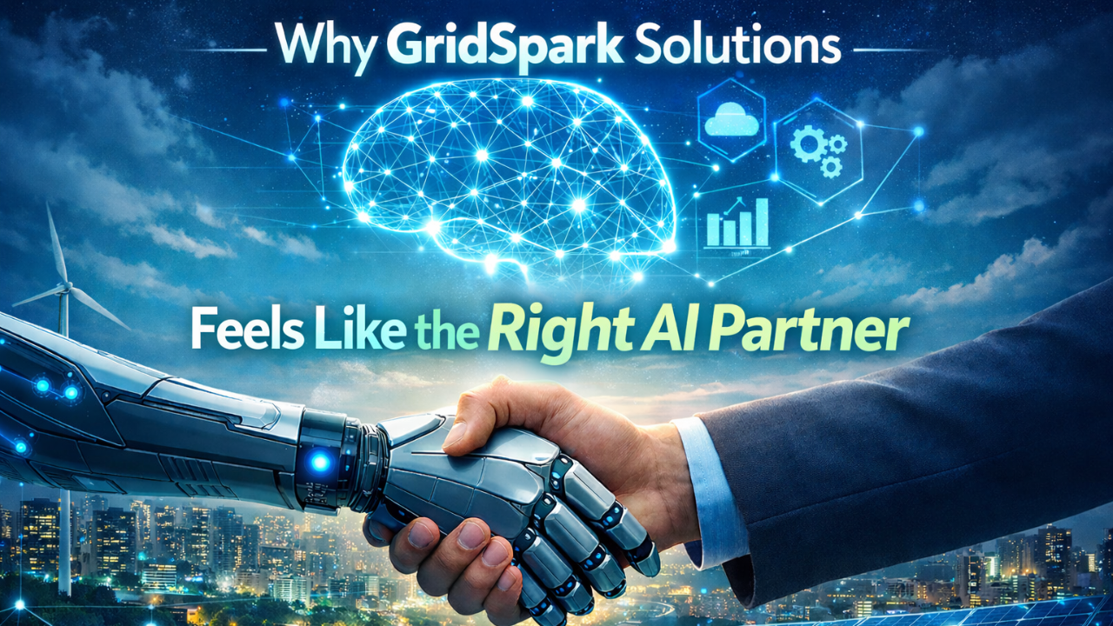

GridSpark Solutions Starts With Listening — Not Selling
One thing that makes a huge difference? Being heard.
Before talking about systems, models, or automation tools, GridSpark Solutions takes the time to understand your business. Not just what you do — but where you struggle.
Maybe your team spends hours on repetitive tasks.
Maybe your data is scattered and hard to use.
Maybe your customer service needs to scale but you don’t want to hire 10 more people.
Instead of pushing a “ready-made” AI product, GridSpark focuses on solving your specific problems.
Because technology should fit your business — not force your business to change for technology.

GridSpark Solutions Makes AI Feel Simple
Let’s be real. No one wants to sit through endless technical explanations filled with jargon.
You don’t need complicated language. You need clear answers.
GridSpark Solutions believes AI should feel simple and natural. Their goal is to build systems that work quietly in the background — saving time, reducing errors, and helping your team focus on what really matters.
Good AI doesn’t disrupt everything.
It improves everything.
And it should feel smooth, not stressful.

GridSpark Solutions Cares About Results — Not Just Features
A lot of companies will impress you with technical capabilities. But at the end of the day, features don’t grow businesses. Results do.
You care about things like:
- Are we saving time?
- Are we reducing costs?
- Are we working more efficiently?
- Are customers happier?
GridSpark Solutions focuses on outcomes that actually move the needle. Whether it’s automation, smarter data insights, or intelligent systems tailored to your operations, everything is built with one goal in mind — real business growth.
Not hype. Not buzzwords. Just progress.

GridSpark Solutions Understands That Trust Is Everything
When you bring AI into your business, you’re sharing data. Important data.
That requires trust.
GridSpark Solutions takes security seriously. They understand that innovation means nothing if your data isn’t protected. Strong safeguards, responsible handling, and ethical practices aren’t optional — they’re essential.
You should feel confident, not concerned.

GridSpark Solutions Stays With You
Here’s something people don’t talk about enough: AI is not a one-time project.
It evolves. Your business evolves. Your needs change.
That’s why GridSpark Solutions focuses on long-term relationships. They don’t just build and disappear. They support, improve, adjust, and grow alongside you.
It feels less like hiring a vendor — and more like gaining a technology partner.

Choosing the Right AI Provider Doesn’t Have to Be Complicated
Choosing an AI provider doesn’t have to feel overwhelming.
You don’t need the flashiest presentation.
You don’t need the most complicated system.
You need a team that listens.
A team that understands business.
A team that makes technology feel human.
That’s what makes GridSpark Solutions different.
AI should make your work easier, your decisions smarter, and your growth faster. With the right partner, it can.
And when it feels clear, practical, and genuinely supportive — you know you’ve found the right one.

